Take photos of all HMI dryer screens (setup, data, etc.)
Download the desired PLC and HMI software version onto your office PC.

Format the SD card and USB drive to Fat32 prior to copying files to them.
Make sure the “Volume Label” is blank (empty) prior to formatting.

Creating a multi install SD card for use on M221 plc and HMIGTO screens
Format SD card to Fat32.
Extract the zip file for the multi install.
Copy the contents of the “Vxx SD files” directory to the root directory of the SD card.
The SD card root directory will look like this (dates and file sizes will differ somewhat).
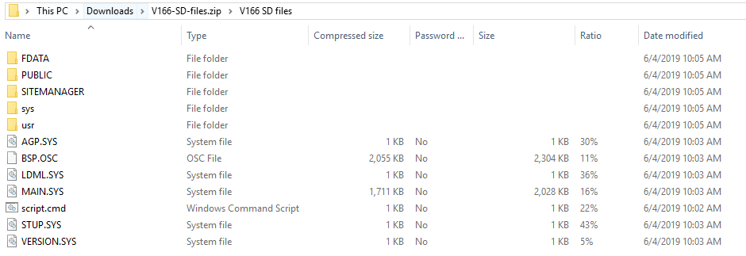

Creating a single install USB drive for use on XBTGT6330 screens
Remove USB drive from dryer HMI.
Format USB drive to Fat32.
Extract the zip file for the single install.
Copy the contents of the “Vxx USB files single install” directory to the root directory of the USB.
The USB root directory will look like this.
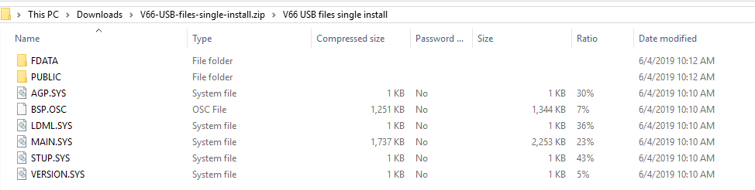
Note: The single install software can be copied to several USB drives for install on multiple machines.

Installing the M221 PLC software
Power off the PLC.
Install the SD card in the PLC.
Power on the PLC.
There should be a solid green PWR led & a solid red ERR led.
The green SD led should be on solid (not flashing) green for 10-20 seconds.
After the SD led goes off, power off the PLC.
Remove the SD card, then power on the PLC.
There should be a solid green PWR led & a solid red ERR.
The solid red ERR should go off ~4 seconds.
Then the green RUN led should light and stay flashing beyond 8 times.
Power the PLC off then back on.
The green PWR led will be on solid & the green RUN led should flash ~8 times then go solid on.

Installing the HMIGTO screen software
Power off the HMI.
Remove USB drive from dryer HMI.
Format USB drive to Fat32.
Replace the USB drive in the HMI.
Install the SD card with the new files.
Power on the HMI.
Install should begin automatically (~2 minutes).
When install complete, remove the SD card, then press the “Restart” icon.

Installing the XBTGT6330 screen software
Keep the HMI power on.
Install the new single install USB drive with the new files.
When prompted, press the “Yes” icon to begin installing.
Do not remove the USB drive.
When prompted press the “Restart” icon.
Leave this USB in the HMI when finished (do not remove).

