Loading program on M241
TURN THE POWER OFF AT 1CB
INSERT THE SDHC CARD
TURN THE POWER ON
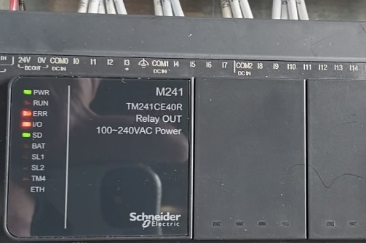
INITIAL LIGHTS WHEN POWER IS TURNED ON

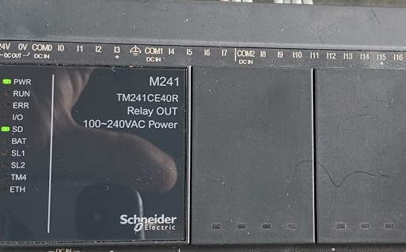
WHEN THE SD LIGHT COMES ON
THE PROGRAM IS LOADED
TURNOFF THE POWER AT 1CB
REMOVE THE SD CARD
TURN THE POWER BACK ON AT 1CB

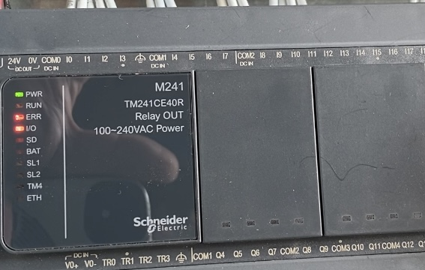
INTIAL LIGHT WHEN POWER IS TURNED ON

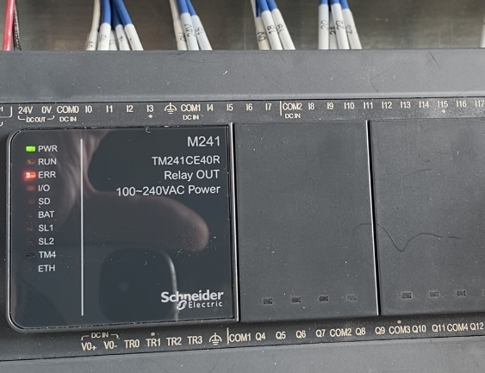
THEN THE ERR LIGHT COMES ON

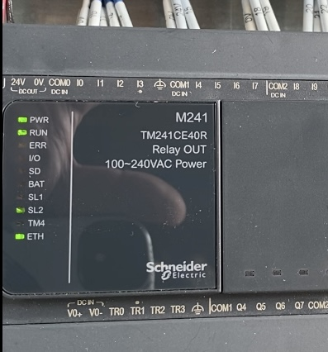
WHEN THE RUN AND ETH LIGHTS COME ON AND THE SL2 LIGHT IS FLASHING THE M241 IS GOOD TO GO.

