PLC Firmware loading
Turn off power—1CB
Insert the SD card
Turn power back on—1CB
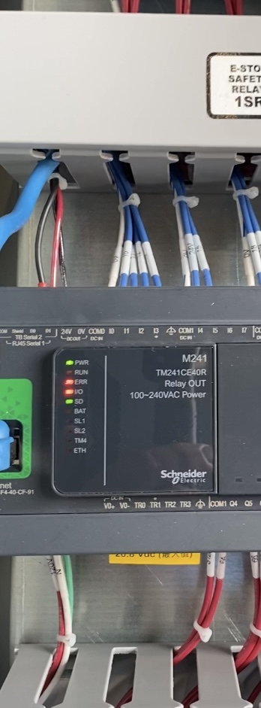 initial lights
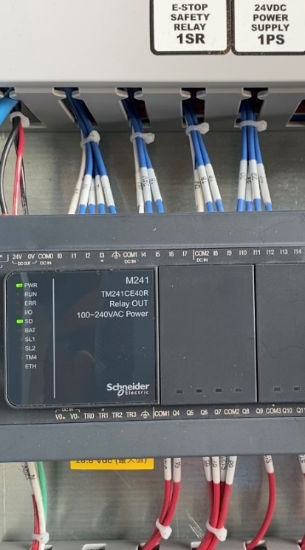SD Light is on for Approx. 2+ minutes
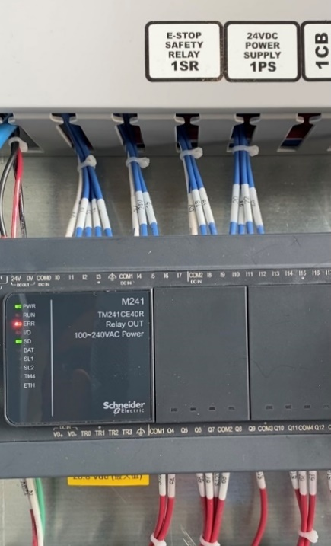ERR light comes on, loading is finished.
Turn power off 1CB, remove SD card

Turn Power back on 1CB

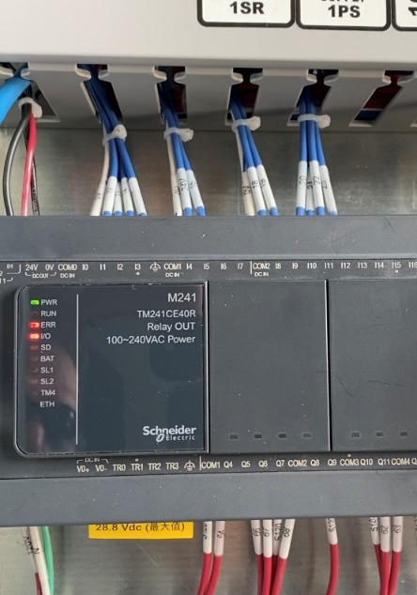

The initial lights

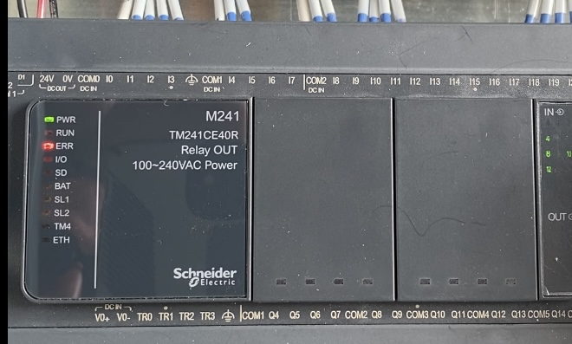
Then just then err light is on.

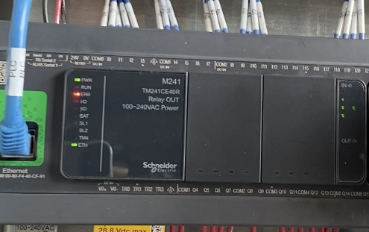

When the ETN (ethernet) light comes on and the err light blinks the PLC is ready for a program.

